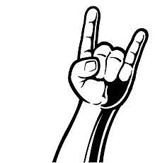

ROCK MY SMILE

Post a picture of yourself wearing your amazing wristband

Tag us in the picture

Put your real name in the comments.

(so we know who ya are)

We will enter you in the summer drawing for a

16 GB IPAD AIR.

Winner will be notified by phone and on Instagram on August 15, 2014

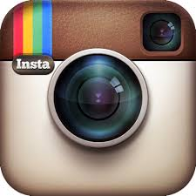Follow us: BrunkLaster

**SUMMER 2014**

**ROCK YOUR WRISTBAND**

**IPAD CONTEST**